

**Green University of Bangladesh**

**Department of Computer Science and Engineering (CSE)**

**Faculty of Sciences and Engineering**

**Semester: (Spring, Year:2021), B.Sc. in CSE (Day/Eve)**

**Course Title: Web Programming Lab**

**Course Code: CSE 302 Section: 203 D3**

**Lab Project Name: Table Tennis Game Using JS ,MySql on Canvas .**

**Student Details**

|  |  |  |
| --- | --- | --- |
| **Name** | | **ID** |
| **1.** | Prodip Sarker | 203002016 |
| **2.** | Johirul Islam | 203002006 |
| **3.** |  |  |

**Submission Date : _ _ _ _ _ _ _ _ 03.11.22_ _ _ _ _ _ _ _ _ _ _ _**

**Course Teacher’s Name : Md. Ashiqussalehin _ _ _ _ _**

**[For Teachers use only: Don’t Write Anything inside this box]**

|  |
| --- |
| **Lab Project Status**  **Marks: ………………………………… Signature: .....................**  **Comments: .............................................. Date: ..............................** |

# Tennis Game

## Using JS

JavaScript is a scripting language that enables you to create dynamically updating content, control multimedia, animate images, and pretty much everything else .JS <canvas> is an HTML element which can be used to draw graphics via scripting (usually JavaScript). This can, for instance, be used to draw graphs, combine photos, or create simple animations.

## Design Goals/Objective

Here we have used canvas with JS to make our game. It will dynamically create graphical elements on canvas which will respond to user input event , for our case it is mouse movement event .But that’s not ll we have also implemented MySql to it to save user progress and other data which will be deemed necessary to be stored .

# Chapter 2

# Design/Development/Implementation of the Project

## Tennis Game On The Canvas

Tennis game codes are written inside the JS functions . All these functions run within the main function which will run within a given time period of milliseconds .

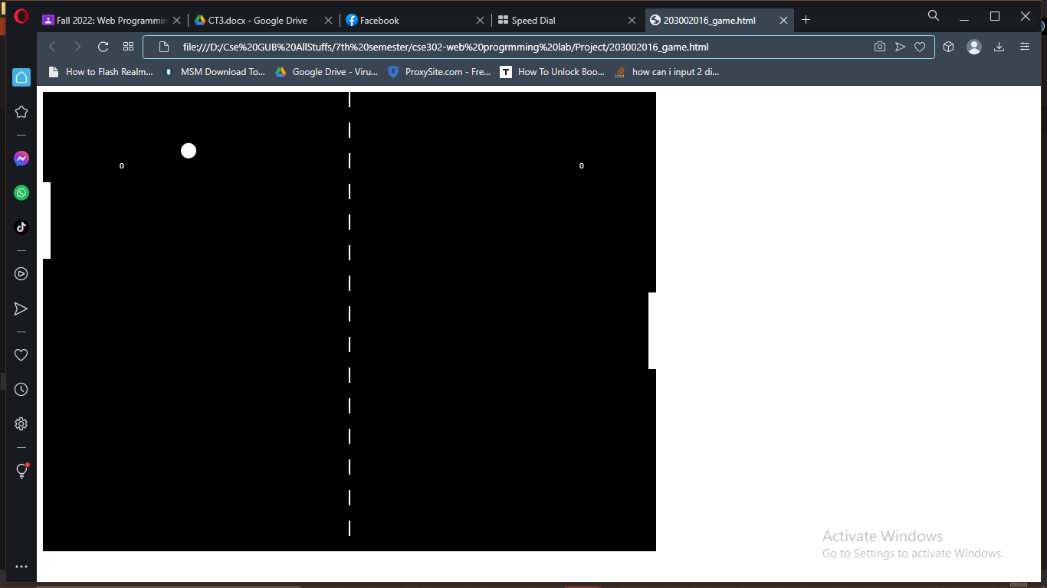

Figure 2.1: Figure name

## Results and Discussions

The game runs quite well with a universal compatibility. The levels get harder as we have implemented an A.I. for it. For finalizing it we have use a MySql with php crud operations .

* + 1. **Results**
    2. **Analysis and Outcome**

# Chapter 4 Conclusion

## Introduction

Discuss the contents of this chapter and summarized description of the work and the results and observation. Generally, it should be in one paragraph.

## Practical Implications

Discuss the practical implications of the project…

## Scope of Future Work

Discuss the future work of the project...

# References

1. Author Initial. Author Surname, Title. City: Publisher, Year Published, p. Pages Used.
2. A. Rezi and M. Allam, ”Techniques in array processing by means of transforma- tions, ” in Control and Dynamic Systems, Vol. 69, Multidemsional Systems, C. T. Leondes, Ed. San Diego: Academic Press, 1995, pp. 133-180.
3. O. B. R. Strimpel, ”Computer graphics,” in McGraw-Hill Encyclopedia of Science and Technology, 8th ed., Vol. 4. New York: McGraw-Hill, 1997, pp. 279-283.
4. K. Schwalbe, Information Technology Project Management, 3rd ed. Boston: Course Technology, 2004.
5. M. N. DeMers, Fundamentals of Geographic Information Systems, 3rd ed. New York: John Wiley, 2005.
6. M. Bell, et al., Universities Online: A survey of online education and services in Australia, Occasional Paper Series 02-A. Canberra: Department of Education, Science and Training, 2002.
7. Bdren, http://vsession.bdren.net.bd/faculty/classSchedules. [Accessed date: 13.09.21]